CHAPTER 3
Labour Supply and Public Policy: Work Incentive Effects of Alternative Income Maintenance Schemes

Answers to End-of-Chapter Questions

1. (LO2) This can be seen by examining Figure 3.1. The income level at the post-demogrant equilibrium E_{d} is higher than that associated with E_{o}. The reason underlying this result is the income effect. As income rises, the person purchases more leisure, which is a normal good. The person will thus work fewer hours, and income earned from working will fall. Total income, including both the demogrant and the earned income, will rise.

2. (LO4) If the individual is fully disabled, there are no work disincentives. They are constrained to work 0 hours, which means that they will locate on the right edge of the income/leisure diagram under any economic circumstances. Regardless of the amount of the demogrant (the compensation payment), they will always be located on that edge at H_{f} hours of leisure in Figure 3.9. The equilibrium occurs at the intersection (there will not be a tangency) between the wage constraint line, which for this person is only a point whose coordinates are (H_{f}, the amount of the demogrant), and the highest possible indifference curve.

3a. (LO1, 2) Unwilling to go on welfare because the welfare payment is too low: The wage constraint line is tangent to an indifference curve which is higher than the indifference curve which touches the corner of the wage constraint line at the right corner of the diagram. In other words, there is an interior solution giving a positive amount of work, and that indifference curve is higher than the one which intersects the demogrant segment, the vertical segment rising from the horizontal axis at T hours of leisure. Recall that at these corner solutions, the slope of the indifference curve does not equal the slope of the budget line. (See Figure 3.3 of the text)

3b. (LO1, 2) Indifferent between welfare and work: The wage constraint line is tangent to the same indifference curve which touches the corner of the wage constraint line at the right corner of the diagram. In other words, there is an interior solution giving a positive amount of work, and that indifference curve intersects the demogrant segment, the vertical segment rising from the horizontal axis at T hours of leisure. (See Figure 3.3 of the text)

3c. (LO1, 2) Induced to move off of welfare because of an increase in his wage: see Figure 3.3, panel b. The welfare equilibrium is E_{w}, while the working equilibrium is E₁.

3d. (LO1, 2) Induced to move off of welfare because of a change in preferences: see Figure 3.3, panel d. Imagine the slope of the indifference curves becoming flatter. That corresponds to the individual valuing income relative to leisure more than she did in the past. The equilibrium would jump from the right-hand corner (welfare) to a smooth interior solutions (working). (See Figure 3.3 of the text)

3e. (LO1, 2) Induced to move off of welfare by a reduction of the 100% implicit tax on earnings: see Figure 3.3, panel c. When welfare benefits are withheld dollar for dollar against earnings, the wage constraint line is flat at the level of the demogrant. If this confiscatory tax is lowered, the budget line has a negative slope, but it will not be as steep as the remainder of the wage constraint line unless the implicit tax rate is 0. The equilibrium E_{w}', which involves working, dominates E_{w}, which does not involve working.

4. (LO1, 3) In that figure contained in the worked example, point D would move over to the right, at 44 weeks of leisure. Because the wage replacement ratio is still 0.6, and the benefits can be paid for 20 weeks, the vertical distance from D to C is still (0.6)*20*wage. Because the duration of benefits is the same, if one works more than 32 weeks, one cannot collect all 20 weeks of benefits, as there are only 52 weeks in a year, and during any given week, one cannot collect both wages and benefits. Each extra week worked beyond 32 weeks implies that one less week of UI benefits could be collected. For the final portion of the wage constraint line, from 52 to 32 weeks of work (from B to A), the opportunity cost of leisure is equal to (wage - 0.6*wage), which is the difference between the wage and the amount of UI benefits. That quantity also gives the slope of the budget line. In summary, the only difference in this case is the portion FDC. In order to change the position of the other kink (the one on the left), one would have to change the maximum length of time for which the benefits are paid.

For the second part of the question, as the replacement rate increases from 60% to 67% of former earnings, the distance between the two parallel portions would increase (the distance DC would be greater), and the slope of the left-most segment AB would decrease. Overall, this is a tough problem.

5. (LO1, 4) We are assuming that the disability is partial, so that the worker can work a little. The segment E_{o}Y_{d} in Figure 3.9 would be almost flat. Without a compensation program, the worker would forfeit the wage for each hour not worked. Now she forfeits only 10% of the wage that would be paid. There is an incentive to work, albeit a very slight one. There is thus a minor substitution effect. For each hour worked (a movement from right to left), the worker gains 10% of her wage. The equilibrium is very likely to be at the corner (as in Figure 3.9b), which means that all H_{f} hours of the time endowment are allocated to leisure.

- (LO1, 2) The figures for program activity indicate that starting in 1995, there has been a continual and marked decline in the number of beneficiaries adjusting for the size of the population. Between 1988 and 1995, however, the opposite trend was observed. From about 1988 and after, we observe a fairly strong positive correlation between the unemployment rate and the beneficiary to population ratio, indicating that in bad (good) times, the rate of recipiency goes up (down). This countercyclical pattern is to be expected. Starting in 1996, welfare benefits were cut drastically. These observations are not subject to debate. (See Figure 3.4 of the text)

The proponents of welfare ‘reform’ claim that the combination of an improving labour market and a much lower level of generosity of benefits caused many recipients to get off of social assistance and enter the labour market. The cut in benefits made receiving welfare benefits less financially attractive relative to working, acting as a push factor on the supply side. Greater opportunities for employment made working more financially attractive relative to receiving social assistance, acting as a pull factor from the demand side. There was a tremendous income effect at work pushing recipients into the labour market: they could no longer afford not to work.

The opponents of welfare ‘reform’, of which there were many, claim that although the rate of recipiency decreased by quite a lot, one has no way of knowing whether those who left the welfare rolls obtained gainful employment or not. Among those who remain on the rolls, it is certain that they are experiencing great economic hardship. This group points out correctly that according to the existing research, one cannot disentangle the effect of an improving labour market from the effect of a decrease in the generosity of benefits. This group tends to argue that if ample jobs that pay reasonably high wages are available for able-bodied welfare recipients, they will accept them and leave the welfare rolls regardless of the generosity of welfare benefits.

7. (LO1, 2) Transitory factors pertain to events which are thought to be temporary and/or random, such as job loss (provided that the worker has some marketable skills), temporary disability, bad luck, temporary personal difficulties that inhibit working (marriage breakup, death in family), personal bankruptcy, etc. This regulation, which is akin to term limits that are imposed on certain politicians holding elected office, would probably not have much of an impact on individuals who suffered income losses for such reasons. Presumably, they have been gainfully employed and self-sufficient in the past, and can regain that situation in the future. This policy measure was designed to discourage long-term dependence on social assistance whereby it becomes the sole source of income for the beneficiary over a period spanning many years. Individuals who fare poorly on the job market – for reasons such as low skill level, poor working habits, partial disability, or residing in an area with a depressed labour market – could be affected by this policy measure. It is designed to give them a strong incentive to return to the labour force and become at least partially self-sufficient. Most policy analysts would recommend that this policy be accompanied by other programs designed to facilitate this transition, such as job training and child-care programs.

Answers to End-of-Chapter Problems

1. (LO3) The simple response is that compared to the design of present social assistance programs, the work disincentives of the negative income tax program are a major improvement. It is true, however, that compared to an economy with no social assistance whatever, the work disincentives of the negative income tax program are notable. In addition, there is widespread agreement among most observers that it is crucial for social assistance recipients to have some work experience, even if it is initially low paid. Even in the face of some work disincentives caused by a negative income tax program, the hours that they are working way well lead to more favourable labour market outcomes in the future.

2. (LO2) Most jurisdictions allow welfare recipients to earn a small amount of labour market earnings before the tax-back of welfare benefits begins. There are typically called allowable, or disregarded, earnings. Referring to Figures 3.2 and 3.3, the wage constraint line starts at the right-hand edge of the diagram with a vertical segment whose height represents the amount of the demogrant. If the implicit tax rate is 0 on the first few hours worked, then the wage constraint line has the same slope as the left portion. The constraint facing the worker has the same slope as the wage constraint line. If there is a 100 % implicit tax rate imposed on all hours of work past 4 hours (to take an example), then the wage constraint line has a kink. Going from right to left (increasing work), this portion is horizontal. It will join the market earnings wage constraint line.

For the second part of this question, the government of Ontario increased the amount of labour income disregarded, at the same time reducing the overall level of benefits. To analyse the expected impact on the labour supply of a prospective welfare recipient of this change in the welfare program, start at the point of no work. The budget line starts at a lower level of income (that corner appears at a lower level), but from the right edge, the wage constraint line has a slope of -w, where w represents the market wage. When the worker reaches the threshold of allowable work, the wage constraint line becomes horizontal. These changes are expected to increase labour supply. As the demogrant is lowered, less leisure (hence more hours are worked) is consumed due to the income effect. The wage paid for working applies to a greater number of hours, so the positive substitution effect is allowed to work over a greater number of hours for each individual. When the earnings disregard is used up, there is no longer any incentive to work on the margin.

3. (LO1, 2) This is a difficult question. Compare Figure 3.5 (the case of the negative income tax) to Figure 3.6 (the case of a wage subsidy). It is probably easier to think of holding the post subsidy income constant. For the latter, it is the ordinate of E_{s}. For the former, it is the ordinate of E_{n}. If we were to superimpose them on a diagram with U_{o} and the no-subsidy equilibrium of E_{o}, the work level would be higher for the wage subsidy. This is because the wage subsidy has no demogrant portion, and a demogrant reduces work incentives. The wage subsidy increases the opportunity cost of not working, which has a positive substitution effect of inducing more work. On the other hand, the negative income tax program has a positive substitution effect too, but since the wage received is lower under this plan, the magnitude of the substitution effect is not as strong.

- (LO2) The reservation wage is always determined by the slope of the indifference curve at the lower right-hand corner of the budget constraint, which is the point of 0 hours worked and 16 hours allocated to leisure. The point (16, $100) appears on the budget line in all cases. When traveling expenses are $40, non-labour income is reduced to $60. The point (16, $100) is still part of the budget constraint, but the budget line is discontinuous. The linear part has a slope of -20 (reflecting the hourly wage), and the endpoints are (14, $60) and (0, $340). If they work 14 hours per day, the total income is 14*20 + 100 – 40 = $340. Note that the worker does not have the option of working either 15 or 16 hours, because two hours are consumed by commuting in any case when they decide to participate in the labour force. In the second case, the slope of the budget line is the same, but the endpoints are (12, $60) and (0, $300). Note that another portion of the budget line has been truncated, and the budget line has been shifted downwards. In the final case, the slope of the budget line is the same, but the endpoints are (14, $ 40) and (0, $320). Note that the portion of the budget line that was truncated (for 3 or 14 hours of work) has now been restored, and the budget line has been shifted upwards relative to the case for which commuting time was 4 hours.

For the first change, the increase in commuting time lowers the budget line, which will only cause an income effect. If the solution is an interior one (with a tangency), then they will work more hours, because leisure is a normal good. This change in the budget line will make the decision to participate much less likely. Recall that the person does not participate if the highest possible indifference curve that is attainable intersects the budget line at the right-most point of (16, $100). For the second change, the increase in the cost of commuting lowers the budget line relative to the original case, which will only cause an income effect. If the solution is an interior one (with a tangency), then they will work more hours. This change in the budget line will also make the decision to participate somewhat less likely, although not as much as in the previous case. Recall that the person does not participate if the highest possible indifference curve intersects the budget line at the right-most point of (16, $100)

5a). (LO1, 2) Note that on the graph, the units are hours worked per year in the horizontal axis and earnings per years on the vertical axis. The budget line has kinks. Since there is no demogrant, the vertex on the right side is the point (T,0), meaning that if 0 hours per year are worked, the worker earns nothing from the employer, and collects no EITC benefit. For the first segment of the budget line, the wage for the first hour worked is W + 0.34*W = 1.34*W, which is therefore the absolute value of the slope. When W* hours = 10540, the total EITC = W*hours*0.34 = 3584 (approximately), and the worker earns only W for each hour worked beyond that point. The absolute value of the slope of the next segment is W. This kink occurs at (T - 10540 / W) hours of work. When the worker earns more than $19,330, the EITC benefit that they have collected is subjected to clawback, which means that they have to start giving it back if they earn more money on the job market. We are told that the clawback rate is $0.16 per dollar earned, so the wage for the next hour worked is W - 0.16*W = 0.84*W, which is therefore the absolute value of the slope of the third segment. The second kink occurs at (T - 19330/ W) hours of work. When the worker reaches the earnings level of $41756, the absolute value of the slope of the budget line reverts to W. The position of the final kink is (T – 41756 / W) hours of work.

b) (LO1, 2) It is designed very much to affect the worker’s behaviour through a positive substitution effect. As the wage level increases, the substitution effect implies that the number of hours worked increases, and the income effect works toward fewer hours of work. For low-wage workers, assuming that their level on non-labour market income is low, it should increase the number of hours that they work. If the level of non-labour market income is fairly high, however, it might not have this effect.

c) (LO1, 2) For an individual was not working in the absence of the EITC, they will participate in the labour market in order to collect benefit. Therefore the program will increase the labour market participation rate.

d) (LO1, 2) The Canadian program, WITB provides no credit until labour earnings reach a minimum of $3000. For any individual who was not participating before WITB, they have to work at least $3000/1.34*W hours initially in order to collect any benefit. Adding $3000 threshold will increase worker’s working hours for each segment of the budget line. For the second segment, additional $3000/W hours is added and for the third segment, $3000/0.84*W is added.

6. (LO2) For lower levels of work, this budget constraint takes the form of the case of the conventional welfare program. This portion of the budget constraint is horizontal at the level of the benefit ($200 per week), as earnings from work bring about a dollar-for-dollar loss in benefit. For higher levels of work, the worker has the option of participating in the self-sufficiency project. There is a kink in the budget constraint budget, which tilts upward at the point of 30 hours of work, and has a negative slope between the range of 30 and 60 hours of work. Over this range, the budget constraint is much higher than it would be if the worker participated in social assistance, and so it is probable that certain workers can reach a higher indifference curve, and hence make the choice to participate in this project. In this situation, there is an interior solution (a tangency between an indifference curve and this upward-sloping portion of the budget line). This indifference curve would be higher than the one at the right-hand corner; at which hours worked is zero. Whether or not they make this choice depends on their preferences for income versus leisure, which is reflected in the shape of their indifference curves.

7. (LO1, 2, 3) For both of these problems, the approach is to superimpose the diagrams that correspond to each of the schemes and try to fit a single indifference curve (that respects all of the properties of indifference curves: negatively sloped, convex shape, and non-intersecting) that yields two equilibrium choices. Both of these choices could be interior choices that involve some work, or one could be an interior solution and one could be the corner solution (which involves no work). The question then becomes what changes in either the wage rate, the welfare benefit, or the subsidy will push the individual to either go on welfare or work under the EITC scheme. In other words, what factors will push the scale one way or the other?

a) For this question you can window back and forth between figure 3.7a and figure 3.2, and another figure appears below. Try to superimpose the two budget constraints on the same figure. It is possible to draw an indifference curve to be tangent to the ‘phase-in’ segment of the EITC budget constraint and to intersect the flat portion of the welfare benefit budget constraint at the point of no work: (T, E_{w}); that is the corner solution. In this situation the worker is indifferent between receiving the welfare benefit and not working at all, or working a few hours under the EITC scheme. The higher the subsidy that is accorded to work, the steeper the ‘phase-in’ segment of the EITC budget constraint becomes, and the more likely the individual is to leave welfare and work under the EITC scheme. They will reach a higher indifference curve than the one that you have drawn, and it will reach only the EITC budget line. There would be an interior solution. The higher the welfare benefit E_{w}, the less likely an individual is to leave welfare. They will reach a higher indifference curve than the one that you have drawn, and it will reach only the welfare budget line. Over the ‘phase-out’ segment of the EITC budget constraint, it is not possible for an indifference curve to be tangent to both budget lines, nor is it possible for such an indifference curve to intersect with the point of no work. There is thus no ambiguity over this range: welfare will not be adopted. All in all, over the ‘phase-in’ segment of the EITC budget constraint, working under the EITC scheme is usually preferred to receiving welfare, except if the welfare benefit is high and/or the work subsidy rate is low. Over the other segments of the EITC budget constraint, we know that the individual will work.

(See Figure 3.2 and Figure 3.7 of the text)

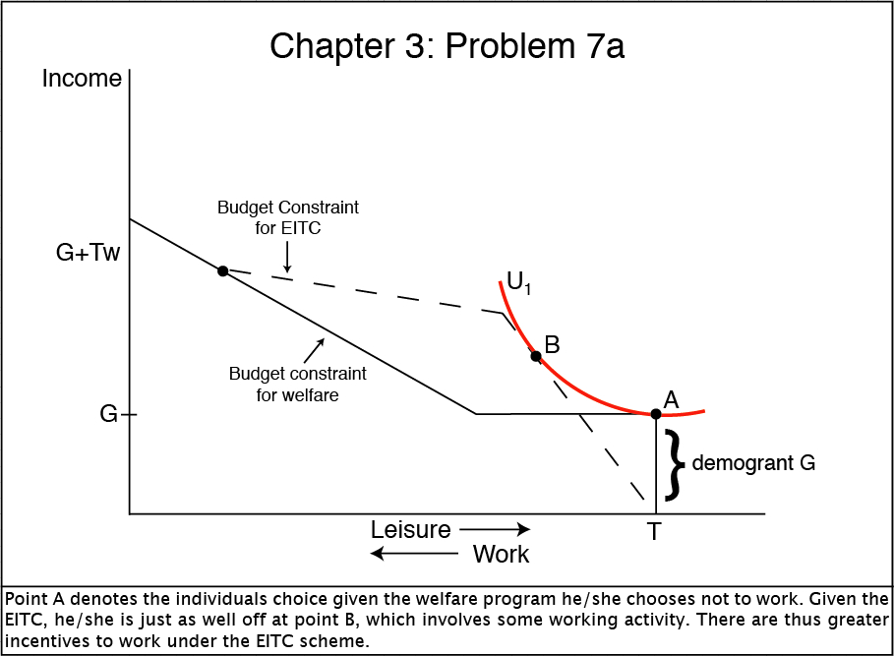

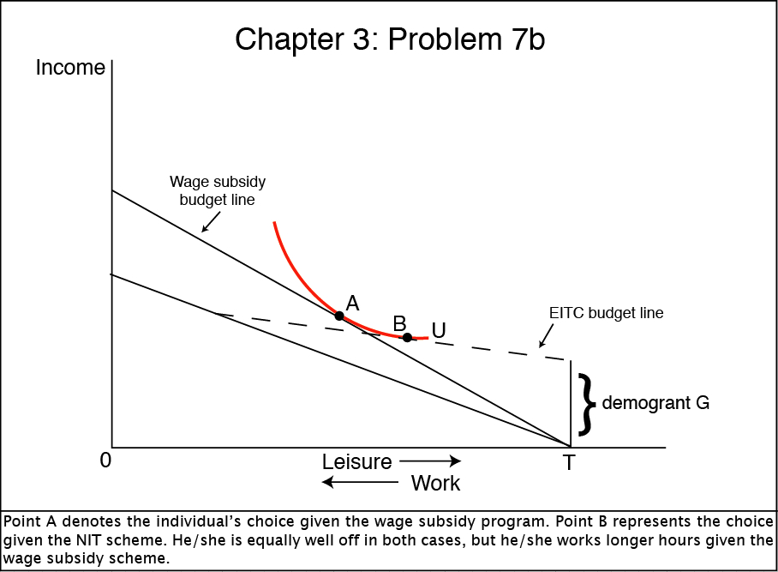

b) For this question you can window back and forth between Figure 3.5 and figure 3.6, and another figure appears above. Try to superimpose the two budget constraints on the same figure. It is possible to draw an indifference curve to be tangent to the wage subsidy budget line (at an upper point) and also tangent to the lower segment of the NIT budget constraint (at a lower point). It is also possible (but unlikely) for an indifference curve to hit the point of no work (T, E_{w}) and also be tangent to the wage subsidy budget line. Given this multiple equilibria situation, the higher the demogrant G, the more likely the worker is to take the NIT scheme in favor of the wage subsidy scheme. They will reach a higher indifference curve than the one that you have drawn, and it will reach only the NIT budget line. The higher the rate of wage subsidy, the steeper the wage subsidy budget line is, and the more likely the worker is to choose the wage subsidy scheme. They will reach a higher indifference curve than the one that you have drawn, and it will reach only the wage subsidy budget line. For low levels of work, the NIT scheme can dominate, while for intermediate and high levels of work, the wage subsidy scheme definitely dominates.

